Two Kings Of The Torres Strait

By Sharona Coutts, Clare BlumerJune 1, 2012
Eddie ”Koiki” Mabo was the leader of the Australian native title fight — playing him in a movie of his life story is Jimi Bani, who has royal heritage of a different kind.

Before actor Jimi Bani would accept the role of Australian land rights pioneer Eddie Mabo, there was something he had to do. "I have to go to Murray Island, to his grave, and I will know the answer, if he wants me to play the role or not," he told Rachel Perkins, the director of the ABC movie Mabo, screening on Australia's ABC TV on June 10.
Bani flew from Cairns to Horn Island then caught an island-hopper across to Murray Island, in the far east of the Torres Strait. He drove deep into the forest, to Mabo's traditional land.
“Acting is my profession, but I will never cross the line of cultural disrespect.”
"Not many people go there," he says. "It's a really sacred place."
He stood at the grave and introduced himself to Uncle Eddie, as he calls the man who revolutionised Australia's legal system by exploding the myth of terra nullius. And then Bani waited for signs that would tell him whether he had Mabo's permission to take the role.
"If it wasn't the right thing, I'd step back," he told The Global Mail. "Acting is my profession, but I will never cross the line of cultural disrespect."
Bani comes from Thursday Island, the administrative centre of the Torres Strait. He needed permission, he explains, before he could tell another tribe's story.
Cultural protocols are taken very seriously across the Torres Strait. For Bani even more so; he happens to be next in line to take over as chief and cultural custodian of one of the main islands.
Bani's father, Adhi Dimple Bani, is tribal chief of the Wagadagam people of Mabuiag Island. He exercises many of the legal powers that Mabo fought to establish under native title legislation.
The very offer to take the part in the film was an honour for Jimi Bani, who one day will assume his father's cultural responsibilities. Already the 30-year-old actor had played the role of an indigenous hero. In his first professional theatrical role, after graduating from the Western Australian Academy of Performing Arts (WAAPA) in 2007, Bani played Jandamarra, who led a resistance to white rule in the Kimberley region of Western Australia in the 1890s.
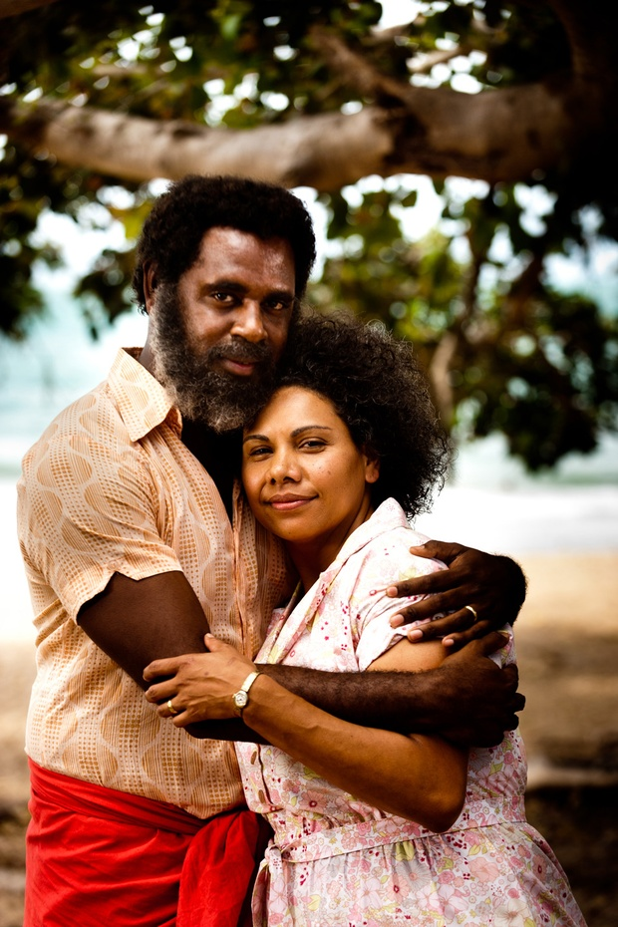

Photo by Matt Nettheim. A Blackfella Films Production for ABC TV.
JIMI BANI as EDDIE MABO and DEBORAH MAILMAN as BONITA in 'MABO'.
But the role of Mabo was even more meaningful, because, like Mabo, Jimi Bani is a man of the Torres Strait. Standing by the grave, he felt nervous and scared.
Then Jimi Bani finally received the sign he needed.
"I just felt a breeze," he says. He heard the nearby bamboo tremble with the wind, and he felt a positive feeling come over him. He took this as Uncle Eddie's blessing.
IT MAY COME AS A SUPRISE to many Australians to learn there is royalty in the Torres Strait. Chiefs still play a very active part in administrative and cultural affairs on the islands. Jimi Bani can trace his royal bloodline back for eight generations to Athe Bani, King of the Wagadagam people, the major tribe on Mabuiag Island.

Photo by Matt Nettheim. A Blackfella Films Production for ABC TV
In court in 'Mabo'.
As chief, Dimple Bani holds authority to most of the land on Mabuiag. He says members of the tribe come to him for advice on a wide range of issues, and seek his permission to enter land to fish or hunt.
"They are governed by our law, even if they are also governed by Australian laws."
Dimple Bani is also custodian of many of his people's traditions, which he says form the bedrock of their culture.
Together with the Queensland government, Dimple Bani has created programs to teach native languages in Torres Strait schools, even on some of the islands where the languages are dormant. He plans to make books of the myths and legends of the Torres Strait, and he is also working on a project to codify what he calls the traditional "structure" of his culture, including land rights, songs, and dances.
When Jimi Bani inherits his father's role, he will also inherit these responsibilities.
JIMI BANI'S UPBRINGING was a far cry from European-style royalty. He remembers living for a time in his paternal grandparents' house, a two-bedroom affair where upwards of 30 people lived, sharing one bathroom, one toilet, and living spaces to sleep.
“Not many people go there. It’s a really sacred place.”
"I grew up sleeping out on the lounge," Bani says, and he certainly didn't get the lounge to himself. "I loved it. It was all 'my spot's here!'" he says, miming the jostling that went on with his brothers and cousins.
The strong family ties have great cultural significance in the Torres Strait, with uncles and aunties accorded similar status to parents in raising children, Bani says.
"The uncles from dad's side — they correct you," says Bani. "The uncles from my mum's side — they teach you. So if I go hunting, I'd go with my mum's side."
But because of Jimi Bani's status, his childhood differed from his cousins and five brothers in important ways. "They treated me like a king basically," says Bani. "I always knew because of the families — how they treated me when I grew up — because of royalty."
At important dinners, he would end up on the grown-ups table, away from the other children. His father describes taking newborn Jimi to Mabuiag Island for the first time.
"The people on the island learned that I had a son, and we went to a function and everybody stood up, even the old women," says Dimple Bani. "They took him from his mum and hugged him."

Photo by Mike Bowers
It's customary in the Torres Strait for maternal uncles to pass down one traditional duty to their nephew: dancing, hunting or gardening (farming) and, Jimi adds, "back in the day you would have warriors that would fight."
Jimi was a shy boy, but when his uncles decided he was to become a dancer, he found expression in the traditional art.
In some ways, acting was a natural progression for him, but when it came to the role of Eddie Mabo, he was pushed into a realm with which he was not familiar — politics.
"I've felt racism," he says. "There is racism in black and white. There is racism in black and black. There is racism in … minority and minority." But, he says, he feels deeply uncomfortable about "political stuff".
"As an actor, I play someone else. But if you ask Jimi about things, that's when I get nervous."
For a man uncomfortable with politics, playing Mabo was a considerable challenge. The movie tells the story of how Eddie Mabo contested the dominance of white laws and forced the High Court of Australia to recognise pre-existing rights of indigenous Australians to their land. His battle lasted for years and sparked a convulsive national debate.
“They are governed by our law, even if they are also governed by Australian laws.”
In its 1992 judgment, the court overturned the doctrine of terra nullius — the legal principle which held that Australia was an empty continent prior to European arrival — saying it "seriously offends the values of justice and human rights".
Wading into the role of Mabo required an understanding of that political history, which Jimi Bani says he didn't have. Fortunately, there were two key women who helped steer him through the process.
The film's director Rachel Perkins grew up steeped in indigenous politics. Her father was Charlie Perkins, who in the 1960s led Australia's Freedom Rides to expose the endemic racism against indigenous Australians.
"I certainly grew up in a family that was highly politicised and put what we saw as 'the cause' first," says Perkins, who told The Global Mail that she recalled the behind-the-scenes discussions as the Mabo case was winding its way through the courts.
Bani says he relied on Perkins's guidance to depict the politics of the time. She stepped in when, for example, Bani was playing a scene with his co-star, Deborah Mailman, who plays Bonita Mabo, Eddie's wife. Bonita was questioning why Eddie continues to fight for his rights, against such steep odds.
After some unsuccessful takes, Perkins approached Bani and asked: "Remember, people like us, at that time, at that same fight — what would that really mean to you?"
He then delivered the lines with calm gravity, instead of anger.
Another woman Bani relied on during the film's production was one of Eddie Mabo's daughters, Gail Mabo.
Gail's family had already granted permission for Bani to play the role, and Gail acted as a cultural consultant on the film.
Watching Bani bring her father back to life was an emotional experience for Gail Mabo, who described shedding many tears as she watched the film progress. During one particular scene at the docks in Townsville, she says she was watching Jimi, dressed as her father, standing on a boat.
"Just behind Jimi I could see somebody else and when I stepped to the left a little more and looked down, it was my dad. He was standing next to Jimi and then he looked at me and he smiled," says Gail. "He smiled such a smile that was like, 'This boy is doing really well'."
When Bani was out of costume later, Gail says she went to him and said: "Brother, you must have done really well today, because dad was standing next to you."
“They treated me like a king.”
GIVEN MABO'S IMPORTANCE to Australian history, Jimi Bani felt enormous pressure to do him justice. He's already experienced a lot of attention in the Torres Strait for his role in the ABC series, The Straits. When it aired earlier this year, Islanders were glued to their TV screens, watching the fictionalised portrayal of crime and violence in their communities.
But Bani expects even more attention for the Mabo film. His father will be among the 30 friends and family at the premiere of Mabo at the Sydney Film Festival on June 7.
"It's going to be very emotional," Dimple Bani says. "I told my son that he's the vehicle that's going to tell the life story of an extraordinary man."
Asked how he felt about the role, Jimi Bani says he could identify with Eddie Mabo. "I'm a strong cultural man," he says. "I understood him inside, internally. That island culture."
Ultimately Jimi Bani will return to the islands to take up his cultural responsibilities. He plans to continue drawing on his skills as a storyteller and a linguist — he speaks two traditional languages, Kala kawau ya and Kala lagau ya — to teach the future generations about their history and culture.
"I'm really and truly a storyteller. I love telling stories and I think taking that back home would be a great thing," he says. "Really, that's my love."

